Redirect Step

Objective

This method is used to redirect the client request to some other location for further processing, the new location is available on a different server or different context, our web container handles this and transfers the request using a browser, and this request is visible in the browser as a new request. Sometimes this is also called a client-side redirect.

UI

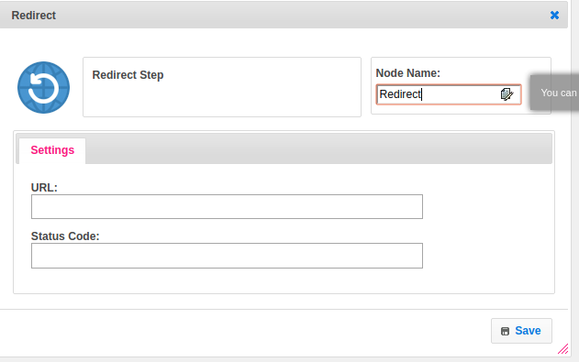

## Attributes

|  |  |
| --- | --- |
| **Attributes** | **Description** |
| **1. URL** | Set the URL to redirect the page. |
| **2. Status Code** | Provide the status code. |

## Executor Description:

Pass the URL to HttpResponse class setRedirect method. Pass the status to HttpResponse class setStatus method.

## Resource:

Please refer the following link to get more information.

<https://www.w3adda.com/servlet-tutorial/servlet-sendredirect>